Innovative Design of Cam-Controlled Planetary Gear Trains
Wen-Hsiang Hsieh^{1,}, Shou-Jui Chen²
¹Department of Automation Engineering, National Formosa University, Yunlin, Taiwan
²Institute of Mechanical and Electro-Mechanical Engineering, National Formosa University, Yunlin, Taiwan
Received 15 June 20xx; received in revised form 05 August 20xx; accepted 10 September 20xx

Abstract
The objective of this paper is to perform the innovative design for the new structures of cam-controlled planetary gear trains (CCPGTs), based on the creative mechanism design methodology. Firstly, the design requirements and design constraints are summarized according to the kinematics characteristics of existing CCPGTs. Then, the (4, 5) and (5, 7) graphs are generated by the theory of number synthesis. After that, the atlas of feasible specialized graphs is obtained. Finally, the atlas of new designs is obtained through the particularization process. In addition, an illustrated example is given, and the feasibility of the design is verified by computer simulation using ADAMS software. The result indicates that news design can produce a more wide range of non-uniform motion than the existing design, therefore they are better alternatives for driving a variable speed input mechanism.

Keywords: planetary gear train, cam, innovation design, variable speed mechanism

Introduction
Cam-controlled planetary gear trains (CCPGT) are planetary gear trains with cam pairs. Chironis [1] illustrated a CCPGT in his book, as shown in Fig. 1. It is composed of a cam groove (the frame), a sun gear (the output), a planetary gear, and an arm (the input), and its exploded view is shown in Fig. 2. In general, the arm rotates at constant speed, and drives the planetary gear to revolve around the sun gear and to spin around itself simultaneously. At the same time, the planetary gear produces an oscillatory motion through the contact of the attached roller and the cam groove. Therefore, the sun gear can produce a non-uniform motion by engaging with the planetary gear. The main advantage is that it can produce a wide range of non-uniform output motion. In addition, it has the advantages of higher reliability, lower cost, faster response, and higher power transmission due to its mechanical nature. It is now at work in film drives. However, the design and analysis of the CCPGT are not easy due to its complex structure. In addition, few studies on the CCPGT can be found in literature or references.
Hsieh [2-3] proposed the method of kinematic design and control for the CCPGT. A CCPGT can be applied to drive a mechanism at a non-uniform speed. This kind of mechanism is called a variable speed input mechanism. And it was seldom investigated before 1990. Hsieh [4] firstly presented a novel approach to improve the state of the motion of the follower by varying the input speed using a servomotor. After that, Yan et al. [5-6] contributed to improve the output motion characteristics of a mechanism by a servomotor solution. Although the method is effective, there are still some disadvantages exist due to the utilization of a servo motor, for instance, higher cost, a specially designed servomotor required, slow response, and limited output power. A new way to drive the variable speed input mechanism is an open topic to be investigated.
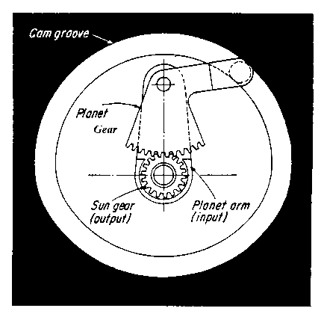
Fig. 1 CCPGT [1]
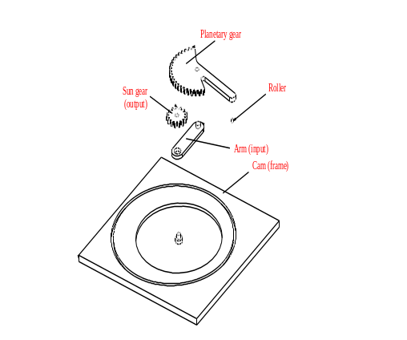
Fig. 2 Exploded view of a CCPGT
The purpose of this paper is to perform the innovation design of cam-controlled planetary gear trains with one degree of freedom. The atlas of new designs with 4 and 5 links will be generated. The feasibility of new designs will be illustrated with an example, and verified by kinematic simulation.
Creative Mechanism Design Methodology
The structural synthesis of CCPGTs will be performed based on the creative design methodology process [7-8]. Fig. 3 shows the flow chart for the approach. The process consists of six steps:
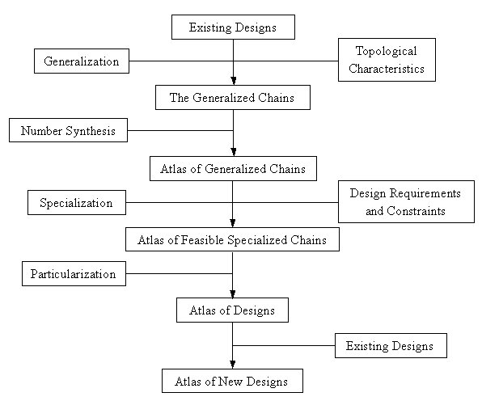
Fig. 3 Creative design methodology
2.1. Existing designs (or original designs)
To search existing design models or study an available new design model with required specifications and to establish the topological structure of these models are the first step of the methodology. The goal of this step is to select some of these models for researching their equivalent mechanism skeleton and kinematic chain for developing the new designs.
2.2. Generalization
The above original designs are transformed individually into their corresponding generalized chains (kinematic chains). The generalized chain will be involved in various types of members (edges) and joints (vertices, or said kinematic pairs) for all possible assembly in the following steps.
2.3. Number synthesis
The atlas of generalized chains and kinematic chains, respectively, with the required numbers of links and joints, are synthesized for obtaining all possible generalized chains that have the same number of links (N) and joints (J) as the original generalized chain.
2.4. Specialization
Specialization is to assign specific types of members and joints to every available generalized chain subject to certain design requirements to obtain the specialized chains. Among, design requirements are determined based on the concluded topological structure of the original designs.
2.5. Particularization
Particularization is the reverse process of generalization. Once a feasible specialized chain is obtained, it is particularized into its corresponding mechanical device in a skeleton drawing.
2.6. Atlas of new designs
Every feasible specialized chain is particularized into its corresponding mechanical device in a skeleton drawing. Therefore, the last step is to identify all non-existing designs from the atlas of designs as the new designs.
Existing Mechanism
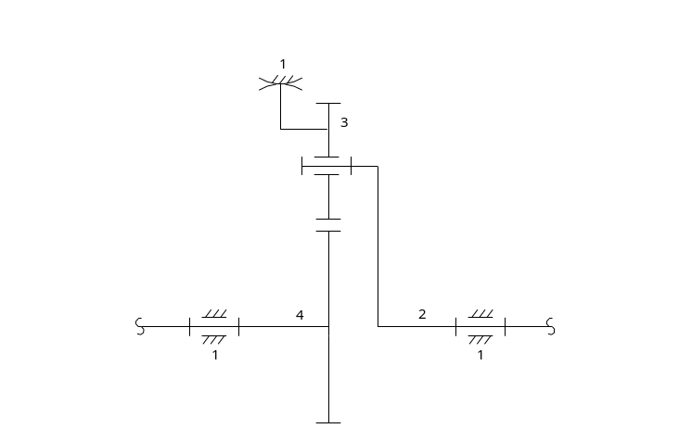
- Structure sketch
Fig. 4 The existing design
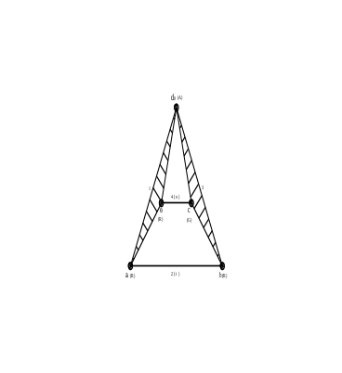
(b) Generalization chain
Fig. 4 The existing design (continued)
The CCPGT in Chironis’s book [1], shown in Fig. 1, is selected as the existing Mechanism for structural synthesis. Fig. 4(a) shows its structural sketch. Fig. 4(b) is the corresponding kinematic chain. It consists of 4 links and 5 joints, denoted as (4, 5) chain, including 3 revolute pairs, 1 cam pair, and 1 gear pair. The design requirements and design constraints are summarized based on the characteristics of the mechanism.
3.1. Design requirements
(1) It has one degree of freedom, therefore one input.
(2) It is a planar mechanism with four links or more.
(3) It has at least one cam pair to generate a non-uniform output speed.
(4) It has at least one gear pair to change the uniform output speed.
(5) It has a ground link to support or constrain other links.
(6) It has one output link.
3.2. Design constraints
(1) The number of links must be 4 or 5 links.
(2) The frame must be a link with three joints or more in order to have a firm support.
(3) At least one cam pair must be incident to the frame.
(4) The input link must be adjacent to the frame with a revolute joint.
(5) The input link, the output link, and the frame, must be assigned on different links.
(6) The input link must be assigned to the arm in order to drive the planetary gear to move around the sun gear.
(7) The arm must be adjacent to a planetary gear with a revolute joint to produce a uniform output rotation.
(8) The output link must be adjacent to the frame with a revolute joint to produce a rotational output motion.
(9) The input link and the output link must be in different loops.
(10) Apart from the input and the output link, all the other links must be a link with 3 or more joints.
Generalization and Number Synthesis
Based on the theory of generalization theory [7-8], the generalized kinematic chain of the existing design, shown in Fig. 4(b), is transformed from Fig. 4(a). According to design requirements (1)-(2) and constraint (1), hence the new designs are planar mechanisms of one degree of freedom and with 4 or 5 links. The equation of the degree of freedoms can be obtained by
F=3(N-1)-2J₁-J₂ | (1)
where F is the degree of freedoms, J₁ is the number of joints with i degree of freedom. The link assortments can be found by
J=J₁-2J₂ | (2)
When F and N are specified, then their corresponding kinematic chains are found and denoted as (4, 5) and (5, 7) chains, respectively, based on the theory of number synthesis. Since a graph is more concise to represent the topology structure and easier to distinguish isomorphs than a kinematic chain, it is adopted here for synthesis. Furthermore, Fig. 5 shows the corresponding graphs of (4, 5) and (5, 7) chains generated by Hsu [9], therefore it is not necessary to generate their atlas of generalized graphs by number synthesis. In addition, the number of graphs for the atlases of (4, 5) and (5, 7) generalized graphs are 3 and 13, as shown in Fig. 5(a) and (b), respectively.
  (4-1) |   (4-2) |   (4-3)
(a) (4, 5) graph
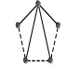  (5-1) | 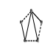  (5-2) | 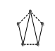  (5-3) | 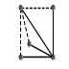  (5-4) | 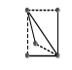  (5-5)
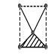  (5-6) | 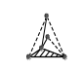  (5-7) | 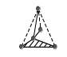  (5-8) | 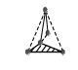  (5-9) | 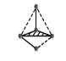  (5-10)
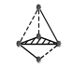  (5-11) | 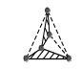  (5-12) | 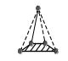  (5-13)
(b) (5, 7) graph
Fig. 5 Atlas of graphs of geared kinematic chains
Specialization
The objective of specialization is to obtain the whole atlas of specialization chains (graphs) by assigning various types of members and joints to each available generalized chain (graphs) subject to the design requirements and design constraints specified above.
According to these design requirements, the specialized joints and members include cam pairs, gear pairs, the frame, the input, and the output. Their symbols and representations are listed in Table 1. The whole process proceeds according to the follows:
Table 1 Graph representations
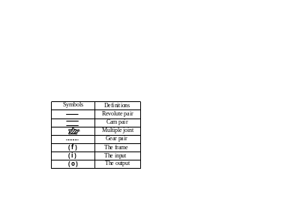
5.1. Assigning cam pairs and gear pairs
As indicated in design requirements (3) and (4), there must be one or more cam pairs, and the same for gear pairs. By assigning them to Fig. 5, 3 and 58 specialized graphs for (4, 5) and (5, 7) graphs are obtained, respectively, shown in Fig. 6(a) and 7(b).

  (4-1-1) |   (4-2-1) |   (4-3-1)
(a) (4, 5) graph
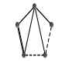  (5-1-1) | 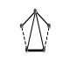  (5-1-2) | 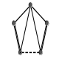  (5-1-3) | 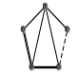  (5-1-4) | 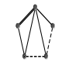  (5-2-1) | 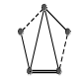  (5-2-2)
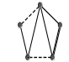  (5-2-3) | 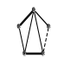  (5-2-4) | 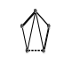  (5-2-5) | 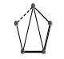  (5-2-6) | 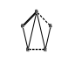  (5-3-1) | 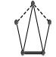  (5-3-2)
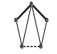  (5-3-3) | 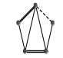  (5-3-4) | 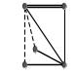  (5-4-1) | 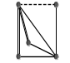  (5-4-2) | 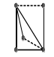  (5-5-1) | 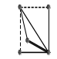  (5-5-2)
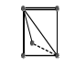  (5-5-3) | 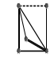  (5-5-4) | 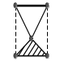  (5-6-1) | 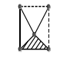  (5-6-2) | 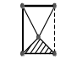  (5-6-3) | 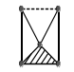  (5-6-4)
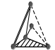  (5-7-1) | 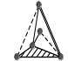  (5-7-2) | 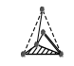  (5-7-3) | 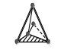  (5-7-4) | 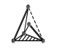  (5-7-5) | 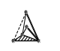  (5-7-6)
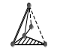  (5-8-1) | 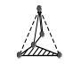  (5-8-2) | 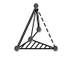  (5-8-3) | 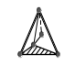  (5-8-4) | 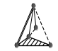  (5-9-1) | 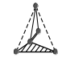  (5-9-2)
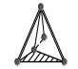  (5-9-3) | 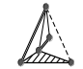  (5-9-4) | 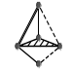  (5-10-1) | 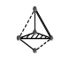  (5-10-2) |   (5-10-3) | 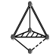  (5-10-4)
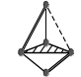  (5-10-5) | 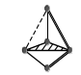  (5-10-6) | 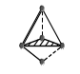  (5-11-1) | 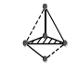  (5-11-2) | 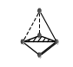  (5-11-3) | 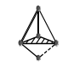  (5-11-4)
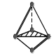  (5-11-5) | 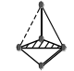  (5-11-6) | 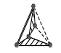  (5-12-1) | 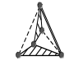  (5-12-2) | 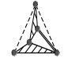  (5-12-3) | 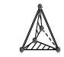  (5-12-4)
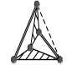  (5-12-5) | 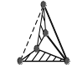  (5-12-6) | 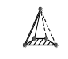  (5-13-1) | 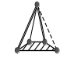  (5-13-2)
(b) (5, 7) graph
Fig. 6 Atlas of specialized graphs – assigning cam pairs & gear pairs
5.2. Assigning the frame (member f)
Since there must be a frame as indicated in design requirement (5), and the frame must be a link with three joints or more, and incident to a cam pair, as stated in design constrains (2) and (3), respectively. By specifying the frame to Figs. 7(a) and 7(b), 1 and 75 specialized graphs for (4, 5) and (5, 7) graphs that meet the above requirement and constraints, are obtained and shown in Fig. 8(a) and Fig. 8(b), respectively.


(4-3-1-1)
(a) (4, 5) graph
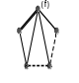  (5-2-1-1) | 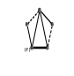  (5-2-2-1) |   (5-2-4-1) |   (5-2-5-1) | 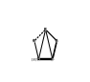  (5-2-6-1) |   (5-3-1-1)
  (5-3-2-1) |   (5-3-2-2) | 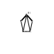  (5-3-3-1) |   (5-3-4-1) |   (5-3-4-2) | 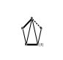  (5-3-4-3)
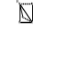  (5-5-1-1) |   (5-5-2-1) |   (5-5-3-1) |   (5-5-4-1) |   (5-5-4-2) |   (5-6-2-1)
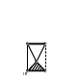  (5-6-3-1) |   (5-6-4-1) |   (5-7-1-1) |   (5-7-2-1) |   (5-7-3-1) |   (5-7-4-1)
  (5-7-4-2) |   (5-7-5-1) |   (5-7-5-2) |   (5-7-6-1) |   (5-8-1-1) |   (5-8-3-1)
  (5-8-4-1) |   (5-8-4-2) |   (5-9-1-1) |   (5-9-1-2) |   (5-9-2-1) | 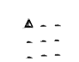  (5-9-3-1)
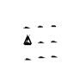  (5-9-3-2) | 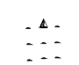  (5-9-4-1) | 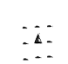  (5-9-4-2) | 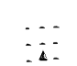  (5-9-4-3) |   (5-10-1-1) |   (5-10-2-1)
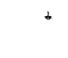  (5-10-3-1) |   (5-10-4-1) |   (5-10-4-2) |   (5-10-5-1) |   (5-10-5-2) |   (5-10-6-1)
  (5-11-1-1) |   (5-11-2-1) |   (5-11-3-1) |   (5-11-4-1) |   (5-11-4-2) |   (5-11-5-1)
  (5-11-5-2) |   (5-11-6-1) |   (5-11-6-2) |   (5-12-1-1) |   (5-12-1-2) |   (5-12-2-1)
  (5-12-2-2) |   (5-12-3-1) |   (5-12-3-2) |   (5-12-4-1) |   (5-12-4-2) |   (5-12-4-3)
  (5-12-5-1) |   (5-12-5-2) |   (5-12-5-3) |   (5-12-5-4) |   (5-12-6-1) |   (5-12-6-2)
  (5-12-6-3) |   (5-13-1-1) |   (5-13-2-1)
(b) (5, 7) graph
Fig. 7 Atlas of specialized graphs – assigning the frame
5.3. Assigning input link (member i)
According to design requirement (1) and constraints (4)-(5), respectively, there must be an input link, it must be adjacent to the ground link with a revolute pair, and it must be a different link with the ground link. Moreover, from design constraints (6)-(7), the arm must be the input link, and incident to a planetary gear with a revolute pair. 1 and 26 specialized graphs for (4, 5) graphs and (5, 7) graphs, as shown in Fig. 8(a) and Fig. 9(b), are obtained by assigning the input link to Fig. 8(a) and Fig. 8(b), respectively.


(4-3-1-1-1)
(a) (4, 5) graph
  (5-6-2-1-1) |   (5-6-4-1-1) |   (5-7-1-1-1) |   (5-7-2-1-1) |   (5-7-5-1-1) |   (5-7-6-1-1)
  (5-8-1-1-1) |   (5-8-3-1-1) |   (5-8-4-1-1) |   (5-9-1-2-1) |   (5-9-4-1-1) |   (5-10-1-1-1)
  (5-10-2-1-1) |   (5-10-5-1-1) |   (5-10-6-1-1) |   (5-11-1-1-1) |   (5-12-2-1-1) |   (5-11-5-1-1)
  (5-11-6-1-1) |   (5-12-1-1-1) |   (5-12-2-1-1) |   (5-12-4-1-1) |   (5-12-5-2-1) |   (5-12-5-6-1)
 |  |   (5-13-1-1-1) |   (5-13-2-1-1)
(b) (5, 7) graph
Fig. 8 Atlas of specialized graphs – assigning the input
5.4. Assigning Output link (member o)
Based on design requirement (5), there must be an output link. Furthermore, the input link, output link, as well as ground link, must be assigned on different link, the output link must not be adjacent to the ground link with a revolute joint, the input link and the output link must be in different loops, according to design constraints (7)-(9), respectively. In addition, according to design constraint (10), all the other links, except the input and the output links, must be a link with three joints or more. 1 and 3 specialized graphs for (4, 5) and (5, 7) graphs, as shown in Figs. 10(a) and 10(b) are generated by assigning the output link to Figs. 9(a) and 9(b), respectively.

(4-3-1-1-1-1)
(a) (4, 5) graph
  (5-6-2-1-1-1) | 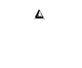  (5-13-1-1-1-1) |   (5-13-2-1-1-1)
(b) (5, 7) graph
Fig. 9 Atlas of specialized graphs – assigning the frame
Particularization
The next step of the creative design methodology is to particularize each feasible specialized graph, by applying the generalizing rules backwards to obtain the corresponding schematic diagram of the CCPGT. Moreover, the atlas of corresponding mechanisms shown in Figs. 11(a) and (b)-(d) is generated from the feasible specialized graph, shown in Figs. 10(a) and 10(b). The input link and the output link are denoted as link 2 and link 4 in Figs. 11(a), but link 2 and link 5 for Figs. 11(b)-(d).
Atlas of New Designs
The atlas of new designs can be obtained by subtracting the existing mechanism from the feasible schematic diagram. The design configuration shown Fig. 10(a) is the same as the existing design in Fig. 4. Therefore, only 3 new designs are synthesized from (5, 7) graph, but none for (4, 5) graph.
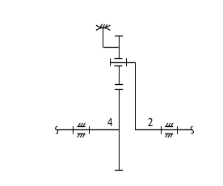
(a) (4-3-1-1-1-1)
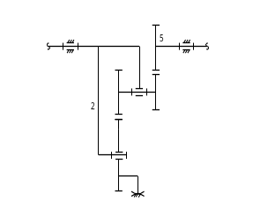
(b) (5-6-2-1-1-1)
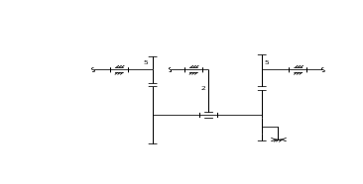
(c) (5-13-1-1-1-1)
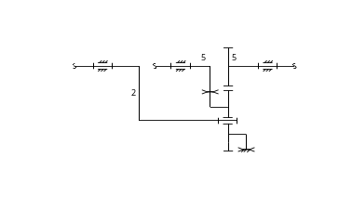
(d) (5-13-4-1-1-1)
Fig. 10 New designs
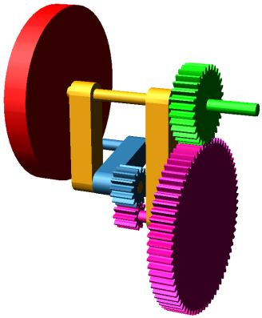
Fig. 11 Solid model
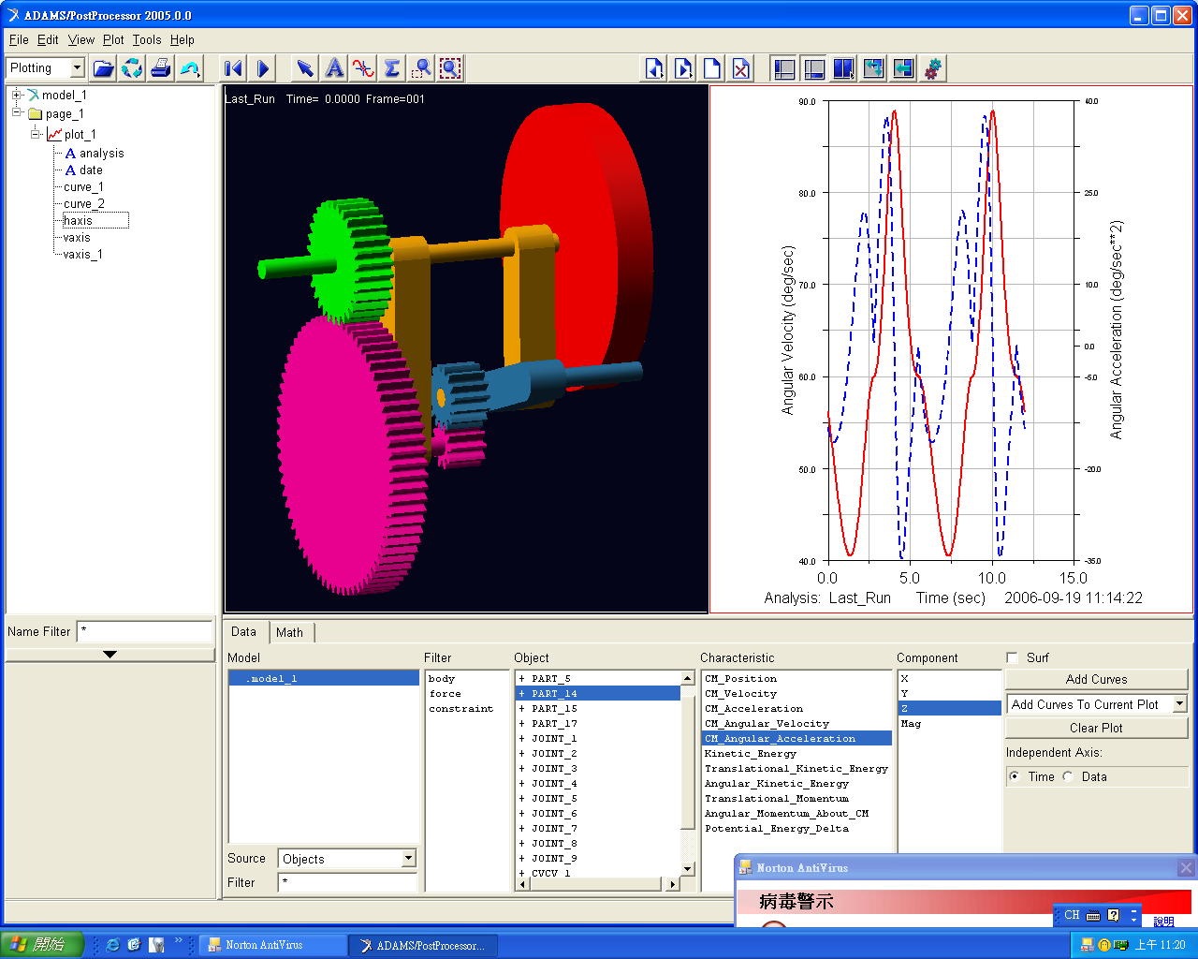
Fig. 12 Kinematic simulation

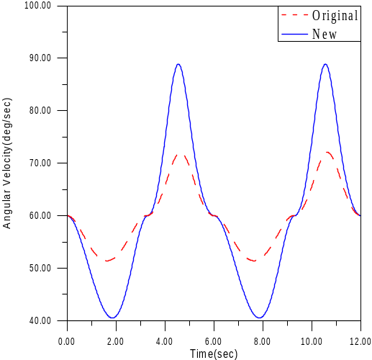
Fig. 13 Comparison
Design Example
After the atlas of new designs is obtained, a detailed design can be carried out by selecting one from the atlas. Here, Fig. 10(b) is selected as a design example, and its solid model is drawn and shown in Fig. 11. Compared to the exist design, the design example has an additional compound gear, therefore much larger speed reduction cam be obtained. Moreover, the numbers of teeth of the sun gear and the planetary gear are set as 30 and 15, respectively, for both the existing design and the design example. The numbers of teeth of gears meshing with the sun gear and the planetary gear is 70 and 10, respectively. And the cam profiles of both designs are identical. After that both designs are introduced into ADAMS software for kinematic simulation. Fig. 12 shows the angular velocity (solid line) and the acceleration (dashed line) of the design example. Fig. 13 shows their comparison. It is found that the maximum angular velocity can be increased about 125%, compared to the existing design.
Conclusions
In this paper, the new designs of CCPGT have been generated in a systematic methodology. Firstly, the design requirements and design constraints are summarized based on the characteristics of the existing CCPGT. Then, the atlas of new designs are obtained through the process of the creative mechanism design approach, and 3 new designs synthesized from (5, 7) graph have been obtained. Finally, the feasibility of the new designs is verified by conducting kinematic simulation. The result has shown that the new designs can produce a more wide range of non-uniform output motion than the existing design, and are better alternatives for driving a variable speed input mechanism.
Conflicts of Interest
Authors must identify and declare any personal circumstances or interest that may be perceived as inappropriately influencing the representation or interpretation of reported research results. If there is no conflict of interest, please state "The authors declare no conflict of interest."

References

- N. P. Chironis and N. Sclater, Mechanisms & Mechanical Devices Sourcebook, 2nd ed., New York: McGraw-Hill, 1996.
- W. H. Hsieh, “An Experimental Study on Cam-Controlled Planetary Gear Trains,” Mechanism and Machine Theory, vol. 42, no. 5, pp. 513-525, May 2007.
- W. H. Hsieh and I. C. Lee, “Modelling and Control of Cam-Controlled Planetary Gear Trains,” International Journal of Modelling, Identification and Control, vol. 12, no. 3, pp. 272-279, April 2011.
- W. H. Hsieh, Improving the State of Motion of Followers by Controlling Cam Speed, Master Thesis, Graduate School of Mechanical Engineering, National Cheng Kung University, 1991. (In Chinese)
- H. S. Yan and W.R. Chen, “On the Output Motion Characteristics of Variable Input Speed Servo-Controlled Slider-Crank Mechanisms,” Mechanism and Machine Theory, vol. 35, no. 4, pp. 541-561, 2000.
- H. S. Yan, M. C. Tsai, and M. H. Hsu, “An Experimental Study of the Effects of Cam Speeds on Cam-Follower Systems,” Mechanism and Machine Theory, vol. 31, no. 4, pp. 397-412, 1996.
- H. S. Yan, Creative Design of Mechanical Devices. Singapore; New York: Springer, 1998.
- H. S. Yan, “A Methodology for Creative Mechanism Design,” Mechanism and Machine Theory, vol. 27, no. 3, pp. 235-242, May 1992.
- C. H. Hsu, “A Graph Representation for the Structural Synthesis of Geared Kinematic Chains,” Journal of the Franklin Institute, vol. 330, no. 1, pp. 131-143, January 1992.


Copyright© by the authors. Licensee TAETI, Taiwan. This article is an open access article distributed under the terms and conditions of the Creative Commons Attribution (CC BY-NC) license (https://creativecommons.org/licenses/by-nc/4.0/).

Corresponding author. E-mail address: allen@nfu.edu.tw

